

Iroquois Ridge High School
The International Business Case Study Series
Assembled by Jeff Boulton

International Accounting Standards

U.S. Accounting Rule Maker Open to Change

FASB chairman sees U.S. adopting global standards within seven years
By Janet McFarland

The top U.S. accounting standard setter said yesterday he believes the United States will be able to adopt the global accounting standards that are being developed for implementation in Europe by 2005. Robert Herz, chairman of the Financial Accounting Standards Board (FASB), which sets U.S. accounting rules, told an international conference on financial reporting in Toronto that adoption of a global standard for accounting is “doable,” perhaps within five to seven years.
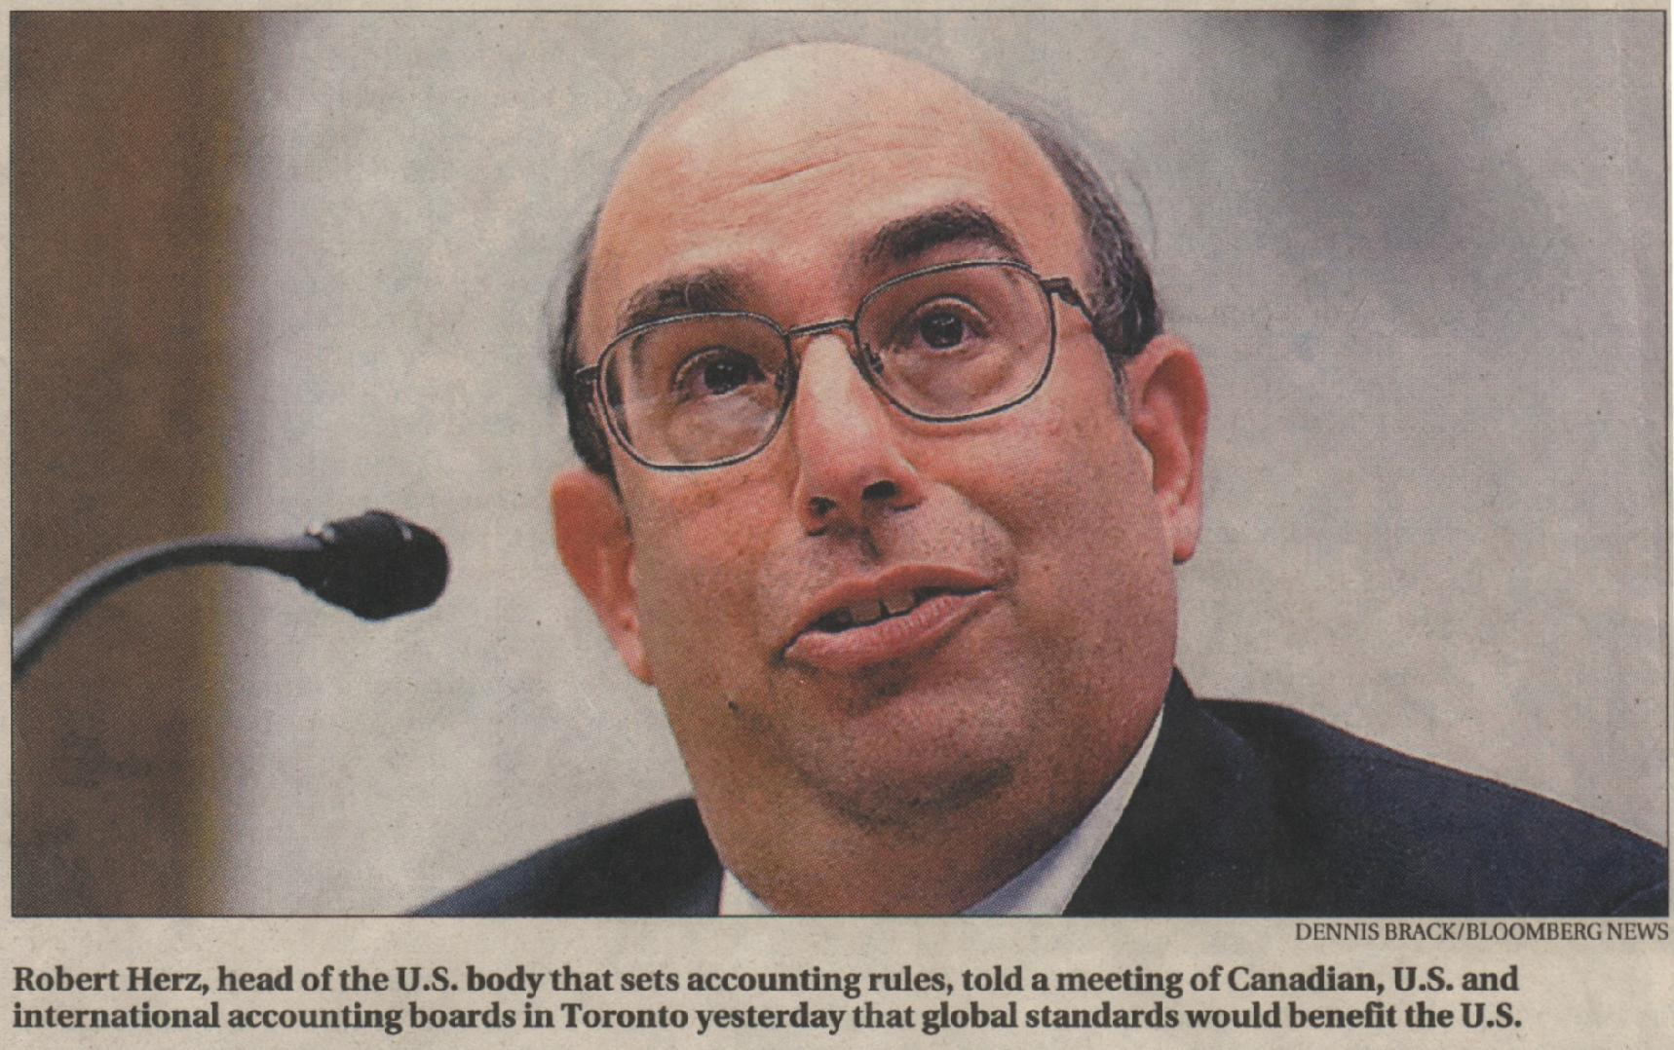
“We are really committed to this effort at the FASB,” he said. “We’re not trying to be the big, bad Americans here. Let’s develop something internationally. It would be good for you, good for us, good for all of us.”
The International Accounting Standards Board (IASB) is currently developing a uniform set of global accounting rules with the goal to develop a global accounting standard by 2007. Members of the European Union have already pledged to start using the common standard by 2005.
International regulators expect the United States to be the toughest country to sell on convergence.
Many countries have expressed skepticism that the United States will be willing to abandon its generally accepted accounting principles (GAAP) in favour of new international standards, and have warned they will not accept global standards that merely copy current U.S. rules to win that country’s support.
Mr Herz, who is in Toronto for a joint meeting of the Canadian, U.S. and international accounting standards boards, said he understands that concern, and said U.S. rules have weaknesses that can be strengthened with the development of new global standards.
“The idea of a kind of pax Americana in financial reporting is probably not a realistic end goal,” he said.
He said American companies are more likely to accept accounting convergence if it occurs in steps, with regulators adopting global standards in a variety of different areas as they move forward.
“Over time, if we’ve eliminated enough differences and put in common standards in enough areas, it’s no longer a big deal,” he said.
Mr. Herz also acknowledged that U.S. regulators will face challenges in selling the idea.
He said companies and accountants “don’t like change” and are comfortable with the current U.S. GAAP reporting system.
“Most people are in favour of convergence as long as you converge to my way,” he admitted. “That won’t work.” He added that many U.S. accountants are also leery about the differences in the international approach to accounting standards with the failure of accounting firm Arthur Andersen LLP following the collapse of Enron Corp.
U.S. standards are generally based on detailed accounting rules that cover many different circumstances, while international standards usually rely more on statements of broad principles. Some U.S. accountants say they prefer detailed rules to protect them from legal liability.
“Accounting firms are in conservative shell-shock mode, and that’s pretty understandable,” Mr. Herz said.
Moreover, he said that companies that wish to preserve the status quo have been effective in lining up political support to prevent change, which is another hurdle the FASB will face. For example, the FASB said in the spring it would study whether to require U.S. companies to expense the cost of their employee stock options, and quickly faced legislation tabled by two congressional representatives to delay any such move.
Mr. Herz said the FASB cannot support “convergence for the sake of it” but must be confident that changes will result in better U.S. financial reporting.
Mr. Herz said he believes the success of convergence in Europe in 2005 will be “critical” in helping to sell the concept in the United States.
“It’s my fervent hope that that goes fairly smoothly, because if it does, I think it will provide further impetus toward truly international standards.”

