Production Requirements

Annual Requirements

Food
Per year

Energy Generation
Per every 1,000 units of GDP that you exceed (ie: $1,000 = ; €1,001 = )

Construction Requirements

Infrastructure Improvements (3 roads + 1 Communication to increase a resource)
Road Communication

Light Industry
Each

High Capacity Factory
Each

Office Tower Construction
Per 10 stories

Any International Action, Summit, or Negotiation
Per deal

Order of Play


- Pay Interest and Fees and Collect revenues (from subsidies and rent)
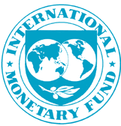
2. Invest, Borrow, or Trade currency.

3. Buy Resources
4. Construct Office Towers
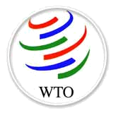

Labour Unrest
5. Settle disputes

6. Adjust your government’s monetary and fiscal policy as you surrender your annual food and oil.
The World Bank

International Arrangements
Subsidiary | Franchisee | Licensee
FACTORY: You own it  FEES: None | FACTORY: You own it  FEES: Pay per resource made | FACTORY: They own it  FEES: Pay per agreement per year

Taxes on Resources
$1 for every 4.9% of corporate taxes
0 – 4.9%  $1 | 5 – 9.9%  $2 | 10 – 14.5%  $3

Rules of Play

Roles to Fill

For the Government:
- Head of State (decides on interest rates, borrowing, tax levels, trade deals with countries)
- Secretary (to record reflections on the “OBSERVATIONS” handout)
For the Corporation:
- CEO – Chief Executive Officer (negotiating, deals with companies, interaction with other corporations)
- CFO – Chief Financial Officer (all calculating, ordering production,

In addition, EMU members’ Presidents must decide as a group on their Monetary and Fiscal policies.

Production

- Each resource starts with a maximum POTENTIAL output of 6 units per year.
- How many units you actually are able to produce depends on how many factories you have on a resource. Large factories produce 3 units per year; small ones produce 1.
- To increase a resource’s maximum potential output, you must invest in both transportation and communication infrastructure.
- Each investment in infrastructure also improves efficiency and thus lowers the cost of production.
Trading

- NOTE: bartering resource for resource is forbidden. You will receive game penalties and MARK penalties.
- Pay for your resources in YOUR currency (money represents labour and production costs etc).
- Pay for others’ resources in THEIR currency.
- You only get to order once per turn. Exact order and change or back of the line.
- Exchanging currency with the World Bank/IMF must be done in denominations of 50.
- No trade agreements exist at the start of the game except for the EU.
- Once nations have an agreement or “Most Favoured Nation Status,” they can’t be stopped from licensing, franchising, or investing in your country, nor can you be stopped from doing the same in theirs.

Foreign Expansion
Franchised
Licensed
Subsidiary

- All real property (buildings, land, factories AND resources) can be owned, purchased, sold, franchised, or licensed.
- Franchised or licensed property can’t be used to produce for anyone except the franchisee, or licensee without his or her consent.
- You can’t unilaterally end any type of agreement.
- Agreements must be in writing and filed with the banker.

Office Tower Construction

- Prices of construction may change without notice.
- Rental rates are fixed unless stated otherwise. Rent is paid in Canadian dollars.
- Once you build a tower, you own that block of land in Toronto. No one else may build there without an agreement.
- A tower laid, is a tower played. It can NEVER be moved again. However, you can pay to have it demolished. Prices vary.
- You must be able to place a finger between buildings.

Debt and Borrowing
The World Bank/IMF Group

- You may borrow amongst yourselves and from the World Bank/IMF Group. World Bank/IMF loans are priced in US dollars.
- Loans must be repaid in the currency in which they were made.
- Interest on borrowed funds, plus 5% of outstanding debt must be repaid at the beginning of each year or assets will be seized. The interest rate is YOUR nation’s rate of interest.

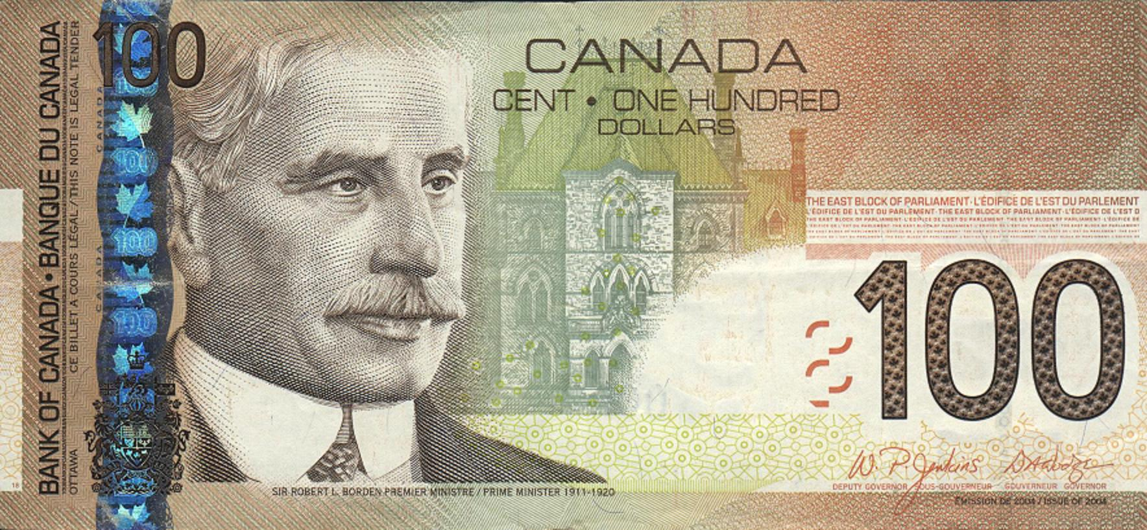
Monetary and Fiscal Policy

- Changing tax rates and interest rates will have a variety of effects. They will impact inflation, economic growth, your currency rate, debt payments, and the subsidies you receive.
- Once inflation hits 10% a year, there’s a high probability you will not be able to produce the resources you need as a result of labour unrest due to eroding salaries.
- The EU President for the day has the final decision on Interest and Tax rates for all EU members.
- Governments can spend their way to higher growth if they wish. You may inject funds into your economy by paying the banker (represents spending on social programs etc.)

Miscellaneous

- Failure at year’s end to pay 1 oil per $1000 of GDP and 2 food per country, will result in a decrease of about 5% of your GDP due to blackouts and starvation.
- It’s your responsibility to ensure the banker enters information accurately
- The game God (that’s me again) may introduce ‘authentic events’ into the game at a whim. Don’t argue with the game God.

Order Sheet

Year 1 Year 2 Year 3 Year 4 Year 5
Oil _________ ________ _________ __________ _________
Minerals _________ ________ _________ __________ _________

Brick _________ ________ _________ __________ _________

Lumber _________ ________ _________ __________ _________

Textiles _________ ________ _________ __________ _________

Food _________ ________ _________ __________ _________

Year 6 Year 7 Year 8 Year 9 Year 10
Oil _________ ________ _________ __________ _________
Minerals _________ ________ _________ __________ _________

Brick _________ ________ _________ __________ _________

Lumber _________ ________ _________ __________ _________

Textiles _________ ________ _________ __________ _________

Food _________ ________ _________ __________ _________

Resource Cost = Base Labour Price + Taxes



International Business Simulation
BBB 4M1

Instructions:

Submit a memo outlining in one brief paragraph the most significant thing you learned or observed from this experience and why it was the most meaningful(make sure it relates to the course).

Include the completed:
- “Reflection” chart (typed as this will be evaluated)

See the rubric below for how these will be evaluated.

Category | Level |  |  |  |  |  | How to Improve
Category | 0 | 1 | 2 | 3 | 4 | Mark | How to Improve
Thinking |  |  |  |  |  |  | Total Thinking Marks: /36
- Identified meaningful, specific, and significant events from the simulation, and  - Related them to the topic in an insightful way.  - Explained how the EXACT same events that were described, are seen or occur in real life, and  - Gave meaningful and significant actual, real-life examples (cite sources) |  |  |  |  |  | /9  /9  /9  /9 | (the “What did I learn” table)  You MUST use actual, SPECIFIC examples.
Communication |  |  |  |  |  |  | Total Communication Marks: /10
Could articulate relationship between game events and their real life equivalent clearly. Includes spelling and grammar.  Half a mark will be removed for each error. |  |  |  |  |  | /10 | (includes proper spelling and grammar, and sentence construction consistent with that of a senior level business student)
Application |  |  |  |  |  |  | Total Application Marks: /25
Present and on time all week, and assisted in set up and clean up each day. |  |  |  |  |  | /5 | Absent -1, late -1/2, no set up or clean up -1/2 (per day)
Used existing knowledge of course concepts to achieve success. This is a GROUP mark. |  |  |  |  |  | /20  or  /20 | Highest Real GDP (1st place 20, last place as low as 9)  OR  Largest number of stories (20 down to 9)

Level 0: never or almost never ~ Level 1: to a limited degree ~ Level 2: satisfactorily ~ Level 3: to a good degree ~ Level 4: excellently

Observations

How do these  affect these | Why do we trade?  What makes it possible? Necessary? | Economic interdependence and convergence | Specialization | World Organizations – pros and/or cons | Impact of exchange rates on international business | Importance of risk assessment in foreign expansion | Modes of entry: how do they affect business? | Importance of infrastructure | Impact of inflation, interest, and taxes | The law of Supply and Demand
Why do we trade?
What makes it possible? Necessary?
Economic interdependence and convergence
Specialization
World Organizations – pros and/or cons
Impact of exchange rates on international business
Importance of risk assessment in foreign expansion
Modes of entry: how do they affect business?
Importance of infrastructure
Impact of inflation, interest, and taxes
The law of Supply and Demand
Connect the concepts on the left, with how they relate or interact with the ones above. (The shaded areas are duplicates, no need to fill them in.) Don’t just list anything. Pick the most insightful events; the ones that “brought it all together” for you.

Reflection

Write up your most significant observations for each. Use actual, real, and SPECIFIC examples for each point. Source your examples using a footnote please. You can find this template online. Type into it, change the font size if necessary. To submit it, please email it to me. Call it reflection.

What makes intl. business possible? Necessary? | Illustrated in the game by:  Is just like this in real life:
Specialization | Illustrated in the game by:  Is just like this in real life:
World Organizations – pros and/or cons | Illustrated in the game by:  Is just like this in real life:
Impact of exchange rates on international business | Illustrated in the game by:  Is just like this in real life:
Importance of risk assessment in foreign expansion | Illustrated in the game by:  Is just like this in real life:
Impact of inflation, interest, and taxes | Illustrated in the game by:  Is just like this in real life:
Importance of infrastructure | Illustrated in the game by:  Is just like this in real life:
Modes of entry: how do they affect business? | Illustrated in the game by:  Is just like this in real life:
The law of Supply and Demand | Illustrated in the game by:  Is just like this in real life:

