Socio-Economic and Political Factors

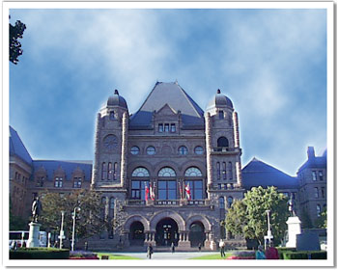
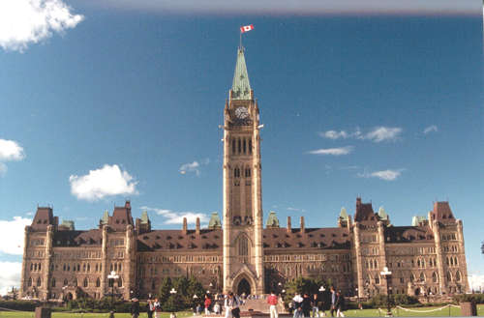
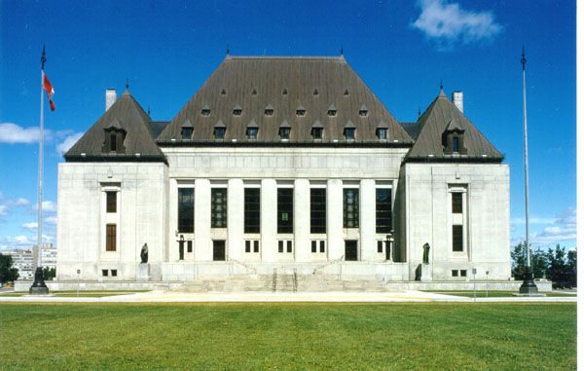

The Economy




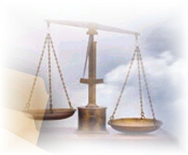

Within Canada alone exists a myriad of complex legal and political systems. Some entities have exclusive power over certain areas, while responsibility is shared for other matters. Then there are the courts, which have the right to review decisions by all governments concerning all matters. Now throw another 200 or so countries into the mix, add their laws, stir, mix a little international law, the international court of justice, pepper with some multi-national agreements (some binding and some not) for flavour, and you’ve got one hell of a mess.

Types of Political Systems and Their Economies

Systems of Government

Democracy (Republics) Totalitarian Varieties

Economic Systems

Market Economies Command Economies
(Capitalist) (Communist)

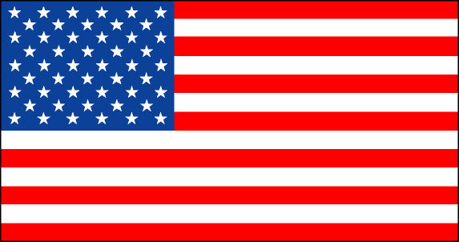
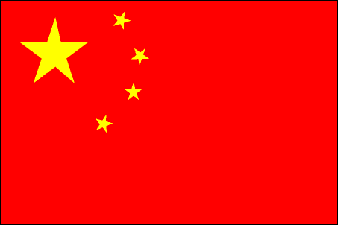
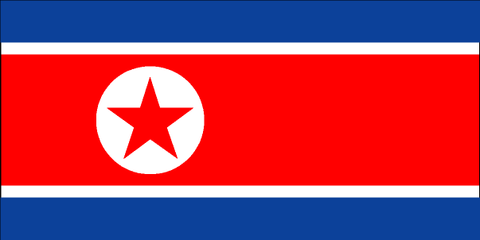
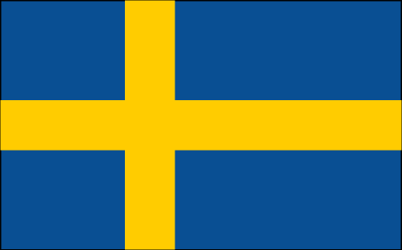
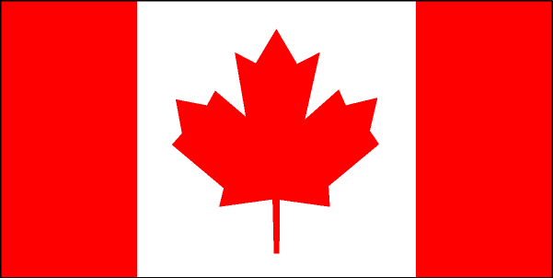

- In the purest sense, there are no true versions of these political or economic systems anywhere in the world, nor have there ever been in all of history. (see ranking on page 289 in text)

- However, nations do fall into a particular order based on their philosophies, practices and policies toward rights, lawmaking, governance, and their overall participation (or interference depending on your point of view) in their country’s economy.

- It is important to note that most systems of government coincide with their “natural” economic systems. (i.e. Democracy with Capitalism). Though this is not a requirement. China is becoming more and more capitalist, but it is still governed in a very authoritarian manner.

A Market Economy:

- Millions of individuals and corporations make the decisions. Collectively their practices, habits and decisions make up “market forces”.
- Encourages ownership of private property
- Individuals are free to make as much profit as they can
- Competition is encourage
- Competition is seen as healthy – leads to innovation and lower prices
- Governments have little direct involvement with business, they let things run their own course
- Foreign investment is encouraged
- Examples: U.S.A., Canada, U.K., Australia
- BIGGEST PRO: Efficient, derives the most prosperity
- BIGGEST CON: Profit drives all decisions, prone to economic cycles, disparities in income

A Command Economy:

- Is centrally planned
- Governments make all decisions including:
- Pricing, wages, production levels and products to be produced, etc.
- Society comes before the individual
- Examples: North Korea, Cuba, former U.S.S.R.,
- BIGGEST PRO: Equality, fast industrialisation, concentrated development
- BIGGEST CON: Inefficient, no incentives for people to work hard or be innovative

A Mixed Economy:

- Falls somewhere in between.

Political and Financial Risks

Political risks arise when government actions threaten the business environment, or economic policies, which in turn threaten the business environment.

There are numerous types of political risks that you should be aware of. They include:
- General Political instability
- Risk of expropriation or interference with ownership of private property
- Risk of interference with operations or production
- Transfer risks of goods or currency coming in or going out of the country.

Things to watch closely to analyse political risks:
- General political stability
- Government policies towards foreign investment (look at government in power – track record)
- Policies and legal factors
- Economic Environment
- Track record in the above (historical)

Financial Risks originate from the fact the international transactions are priced in different currencies, that values of which can change without notice. As well, risk comes from the fact that it is difficult to assess the trustworthiness of foreign clients.

Ways to minimize Financial Risk:
- Foreign exchange management
- Credit analysis
- Insurance

Examples of Political Risk

The First Rule: Know the Territory

When Victor Cardenas, a Cuban expatriate employed by a British joint venture, opened his pizza parlor in Minsk, the capital of Belarus, he knew he faced many challenges. What he didn’t anticipate, however, was having his restaurant closed by the local authorities for selling lasagna. It seems that lasagna was not included in the official Belarusian cookbook, a holdover from the Soviet era which prescribed to the letter the recipes to be followed in all of the country’s restaurants. Fortunately, the Belarusian Department of Public Nutrition allowed Cardenas to reopen 10 days later, after he secured special licenses that let him sell exotic house specialties like ravioli and lasagna.
TYPE | IMPACT
Expropriation  Confiscation  Campaigns against foreign goods  Mandatory labor benefits legislation  Kidnappings, terrorist threats, and other forms of violence  Civil wars  Inflation  Repatriation  Currency devaluations  Increased taxation | Loss of future profits  Loss of assets  Loss of future profits  Loss of sales  Increased costs of public relations efforts to improve public image  Increased operating costs  Disrupted production  Increased security costs  Increased managerial costs  Lower productivity  Destruction of property  Lost sales  Disruption of production  Increased security costs  Lower productivity  Higher operating costs  Inability to transfer funds freely  Reduced value of repatriated earnings  Lower after-tax profits

Rich farmland has made Ukraine one of the world’s premier granaries. In the early 1990s Monsanto targeted this market, selling $38 million worth of fertilizers and herbicides to the agricultural ministry. However, it took Monsanto a year to receive payment, and then only after the U.S. State Department interceded on its behalf with the newly elected president, Leonid Kuchma. Burned by this experience, Monsanto decided to bypass the agricultural ministry and sell directly to private distributors and collective farms. This did not prove to be a wise move because it enraged apparatchiks (a Soviet era term for bureaucrats), who disliked any attempt to reduce their power. Ukrainian prosecutors, acting on behalf of the agricultural ministry, began harassing Monsanto’s customers, asking why they were buying foreign products. Ukrainian courts declared Monsanto’s chemicals unsafe, even though they had passed strict U.S. regulatory requirements. In addition, farmers using Monsanto products were denied licenses needed to export their crops.

