

IRHS

The Standards
of Business
Practice

DEPARTMENT EXPECTATIONS

Due Dates - Common Courtesy & Professional Business Conduct

Only put off until tomorrow what you are willing to die having left undone.
~Pablo Picasso

In business, honesty, timeliness, and punctuality are highly valued. If you anticipate an absence or a problem, you are required to notify your teacher and all group members (if applicable) in advance. It is expected professional conduct!

You are expected to submit all assigned work by the end of school on the due date given. Students who are not capable of meeting this expectation for whatever reason, may submit their work after this point in time as per board policy.

However, after the first assignment has been returned, all those who have failed to submit one will receive a mark of zero. No further assignments can be accepted. Students will have an opportunity to demonstrate their learning on skipped or plagiarized tasks at the end of the semester at a time (and in a manner) that is convenient to ME.

IMPORTANT: There will be NO opportunity to make up these zeros before the very end of the semester - not even for university mark submission in April!

There will be ONE make-up project which will take the form of a major, comprehensive case study write-up. It will incorporate all of your learning from the course.

Submission of Work

ALL WORK shall be submitted electronically by the due date, regardless of the type of task (e.g. case write-up, presentation, etc.). This electronic submission can take the form of Email (preferable), CD, or USB Key.

Minimum Requirements:

- You shall submit the entire project in ONE, SINGLE FILE.
- The file must be compatible with Microsoft Office products.
- The first page shall be blank (for me to insert a rubric).
- Your full name and email address (and nothing else) must appear at the top of this first blank page.
- All Internet sources must be functioning hyperlinks, or I will treat them as material that has not been sourced.
- The file shall be named as follows:

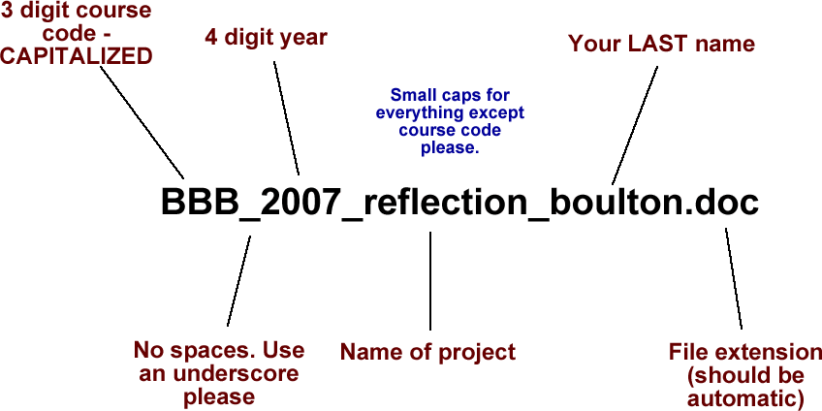

Academic Dishonesty

The dictionary is the only place where success comes before work.
~Anonymous

Only hard work will generate learning and success in life. Academic dishonesty is a serious offence and will come with significant penalties in this course. Often it is a last minute act of desperation. It is our aim to help you avoid issues in this area, by making you aware of what actually constitutes academic dishonesty. The following is a starting list of what we consider to be academic dishonesty as adapted from the definitions of the Senate of Queen’s University and the University of Western Ontario.


Academic dishonesty includes plagiarism as well as any deliberate attempt to gain advantage. Dishonest practices include fabrication of data, cheating, or uttering by a student of false statements relating to academic work.

Plagiarism is presenting work for academic evaluation as one’s own, which in fact was done (in whole or in part) by someone else.

Examples of academic dishonesty include (but are not limited to):

- Collaborating with others on an individual assignment for the purpose of discussion, and then failing to submit unique assignments.
- Making one’s own research available to another student (this includes lending your work to others for them “just to look at” – see #7).
- Using another student's research information unless specifically allowed by the instructor and the student.
- Knowingly fabricating or falsifying research data, or using information known to be false, including making assertions on the validity of unsubstantiated data.
- Submitting work as one’s own that was written in whole or in part by someone else.
- Preparing work for submission by another student.
- Copying work, or knowingly allowing one's work to be copied by someone else for the purpose of academic dishonesty.
- Using direct quotations, or large sections of paraphrased material without acknowledgement.
- Submitting the same piece of work for credit in more than one course without the permission of the instructor(s).
- Unauthorized possession of an examination task, however obtained, prior to the date and time for writing.
- Aiding or abetting any of the above acts.

Fostering Adult Responsibility

Adulthood comes with privileges; privileges come with responsibilities. Accordingly, you are expected to live up to your responsibilities and be punctual, honest, and accountable. You are expected to be mature, and to accept responsibility for the consequences of all your actions

Attendance and Homework

Even a journey of a thousand miles must begin with a single step.
~Lao-tzu

Half of life is showing up. Take the first step! You need to attend class to keep on track of tasks, write quizzes, discover due dates, and learn. Homework is vital for practice as well. Nobody ever learned to play the piano well without practicing. Mastering subject knowledge is no different. Assigned homework is necessary in order to build an understanding of material. Furthermore, having done the homework in advance of a lesson will enable you to get more out of a class.

Work Ethic and Initiative

Man who stand on hill with mouth open wait long time for roast duck to drop in.
-Confucius

You are expected to act responsibly, and work hard. The grade 11 and 12 Business curriculum is rigorous and is designed for students who are preparing for College or University after high school. The pace and content of the courses at this level will correspond to this level of preparation. You will have to stay organized, on task, and work hard or you will quickly fall behind. You are expected to take the initiative to determine (from the teacher not a peer) what you missed whenever absent and to come for extra help if you are having difficulty.

Remaining Current, Global, and Up to Date

When the only tool you have is a hammer, you tend to see every problem as a nail.
~Abraham Maslow

Business is not a stagnant discipline. It is constantly changing and you need to keep up. It is strongly recommended that you make a daily effort to keep abreast of major events that are happening in your time. You should both want to, and feel the need to remain informed in order to offer the in-depth analysis and understanding that is provided by top-level business students. This exposure will enable you to develop your vocabulary, your passion for the subject, and become an active and daily participant in class discussions and activities. Without this up-to-date worldly knowledge, the insight you require will elude you.

